Ideation Phase
Empathize & Discover
Date | 24 September 2026
Team ID | ________________
Project Name | Blog Nest
Maximum Marks | 4 Marks
Empathy Map Canvas:
An empathy map is a simple, easy-to-digest visual that captures knowledge about a user's behaviours and attitudes. It helps the Blog Nest project team understand the needs, expectations, goals, and challenges of its target users.
For Blog Nest, the empathy map focuses on a typical blog reader and content creator. It considers what the user thinks and feels, sees, hears, says and does, along with the user's pain points and expected gains. This helps the team design a simple and user-friendly blogging experience.
Blog Nest – Empathy Map
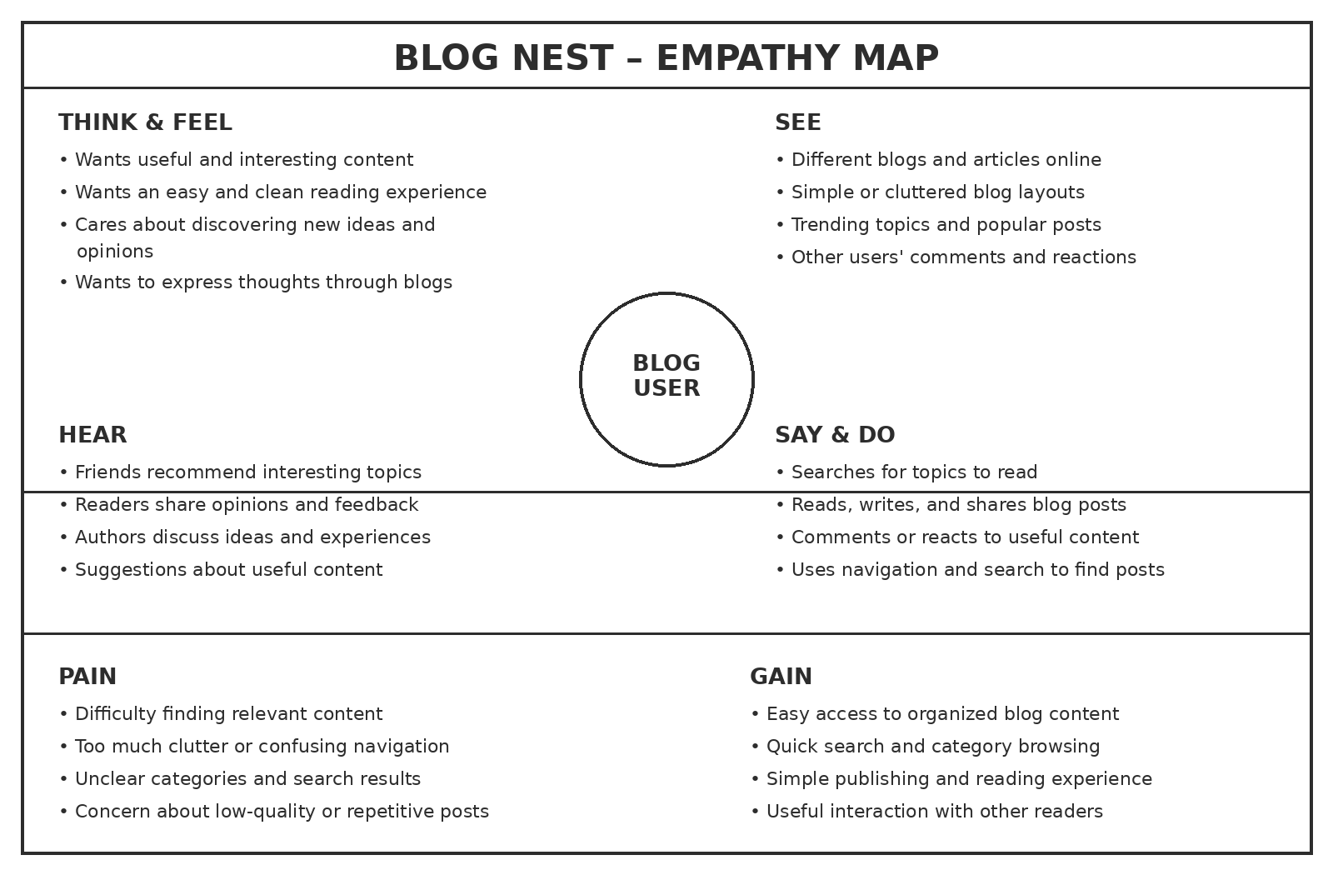
Figure: Empathy Map for Blog Nest users
Reference format adapted from the uploaded Empathy Map Canvas document. The original document describes the empathy map as a tool for understanding user behaviours, attitudes, goals, and challenges.

